Robert George Bentham
“A Family of Soldiers” from the Wigan Examiner, 11th November, 1916.
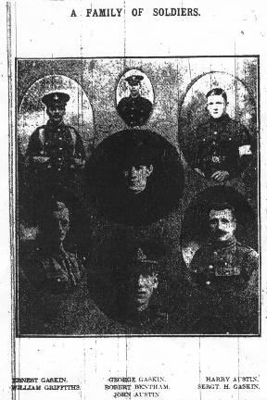
“Above we reproduce a photograph of a patriotic Abram family. Mrs Gaskin, of 167, Warrington Road, Abram, has been notified that her son, Pte. George Gaskin, of the Grenadier Guards, died on 14th September, from wounds received in action. He was a married man with one child.”
(Others are mentioned, then . . .)
“Pte. Robert Bentham is also a nephew and enlisted at the beginning of the year.”

Robert’s photograph is the one in the middle.
Robert was a private (58577) in the King’s Liverpool Regiment, and died on the 5th May, 1917. He was born and resident in Shevington and enlisted in Wigan. Robert has no known grave, and is remembered on the Arras Memorial, fifty miles south east of Calais.
The Arras Memorial commemorates almost 35,000 servicemen from the United Kingdom, South Africa and New Zealand who died in the Arras sector between the spring of 1916 and 7 August 1918, the eve of the Advance to Victory, and have no known grave. The most conspicuous events of this period were the Arras offensive of April-May 1917, and the German attack in the spring of 1918.
Robert’s family
Robert, born in 1887, was the sixth of seven children of William and Maria Bentham living at 93, Shevington Moor. Father was a joiner, William, the eldest son, was a brewery man, Fred was a joiner’s assistant (his dad’s?) and Charles, the third son, a draper’s assistant. It was recorded that William, the father, was deaf. Maria had been born in Chester.
William died in February 1898, and was buried in St Wilfred’s, Standish, which left Maria to bring up the children on her own.
By 1901, William, Charles and Roberta had left home. Fred was a joiner, Nellie worked at the Glue Works, and Robert had a job as a “second kennel boy and groom”. The family lived at 128, Shevington Moor.
By 1911, Nellie had left home, and Robert was now “Kennel man at Hunting Kennels”, at 156, Shevington Moor.
Mrs Bentham obviously did not understand the instruction on how to complete the census schedule; she has listed all her children, and those who are not living there have been crossed out in red ink by the enumerator! She also proudly tells us that the house is “2 rooms downstairs and 3 upstairs” which has been corrected by the enumerator to “5” in answer to the question “How many rooms does your house have?”
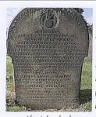
This gravestone was erected for William and Maria Bentham, Robert’s parents, apparently by a friendly society, the “Earl of Surrey Lodge, Standish District, Independent Order of Oddfellows Manchester Unity as a recognition of the above W.Bentham’s 21 years service to the Lodge as Permanent Secretary; also his son Robert George Bentham, killed in Action, May 3rd, 1917”.
Robert’s work
Robert was a groom to Robert Gerard at Wrightington Hall.
“Wrightington Hall was the home of the Wrightington family for several centuries. After 1658 Hugh Dicconson inherited the estate. Eventually the estate passed to his nephew the Hon. Robert Joseph Gerard, brother of Lord Gerard and he added Dicconson to his name, becoming Gerard-Dicconson.”
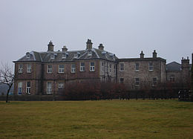
“‛Bobby’ Gerard as he was known never earned the respect of the local people as the Dicconsons had done before him. He was a spendthrift and fanatically addicted to blood sports. He built kennels at the Hall and at the Home Farm, the former being used for breeding hounds. He hunted both the stag and the fox and for the former he kept twelve couples of staghounds at the Home Farm. A description of Wrightington, written towards the end of the last century, stated that the park abounded in deer and game of every kind.” (From an internet source)
Robert Bentham was one of Robert Gerard’s employees.
Wrightington Hall was bought by Lancashire County Council in 1918. Eventually it was converted into a hospital, and Wrightington Hospital was opened in 1933 as a centre for treatment of tuberculosis.
What happened to Robert?
Robert died in the same battle as Frederick Hodge, the Arras offensive of April-May, 1917. Fred was missing from 3rd May; Robert died on the 5th May.
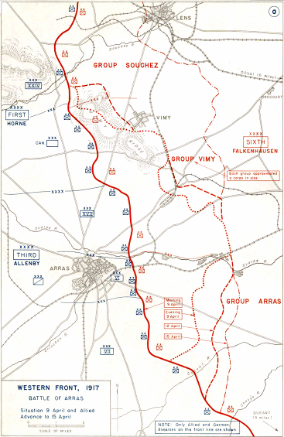
Robert might have been involved in the fighting around the Scarpe River, where a battle was fought on 3rd and 4th May, near Bullecourt.
This map shows the advances made by allied forces up to 15th April. At the beginning of May an attempt was made to push further to the east along the Scarpe River.

“The British launched another attack near the Scarpe on 3 May. However, neither prong was able to make any significant advances and the attack was called off the following day after incurring heavy casualties.” – from Wikipedia.

